Kathleen Brehony, Ph.D.
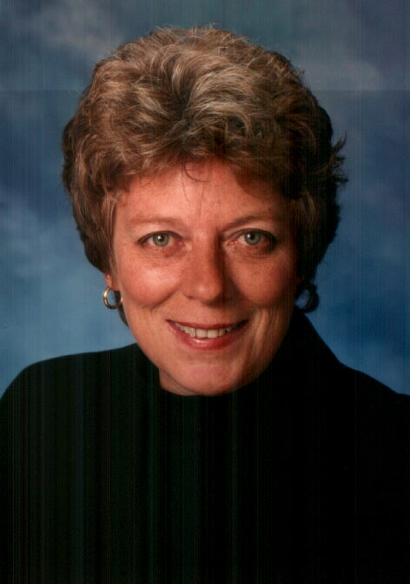

Kathleen Brehony is a writer, personal and executive coach, licensed clinical psychologist, newspaper columnist, and radio producer and personality.
She is the author of the critically acclaimed Awakening at Midlife (Riverhead Books, PenguinPutnam, 1996). This book was honored as a Finalist in the 1996 Books for a Better Life Award. PBS produced an hour-long television special based on this book called “The Midlife Survival Guide.” The program – using Kathleen as writer and talent – aired throughout the United States. Executive Producer and Vice President of Connecticut Public Television – the producing station for the television special – Larry Rifkin refers to Brehony as both “expert and eloquent.”
Awakening at Midlife has been featured as one of the year’s “Books to read” by New Age Journal and excerpted (second serial rights) for Natural Health magazine. This book has also been published in Chinese and Portuguese (Brazil). Hundreds of readers have written with their enthusiastic and positive responses to this author’s wisdom and down to earth language. Actor Robert Urich referred to Awakening at Midlife as “the single most important book I’ve read in my entire life.” Singer/songwriter, Beth Nielsen Chapman calls the book, “simply wonderful.” Jungian Analyst and writer Marion Woodman says, “Kathleen Brehony is bringing Jung to the general public in a very clear, palatable way. Most enjoyable.”
Brehony’s Ordinary Grace -- published in March 1999 by Riverhead Books (PenguinPutnam) -- explores the nature of goodness and is informed by remarkable stories of ordinary individuals who help others in extraordinary ways. This book was featured in the One Spirit Book Club and reviews have been outstanding. Kirkus Reviews: “A heartening inquiry into why ordinary folks routinely go the second mile for others…The quiet strength of this books lies in its storytelling…A restorative tonic, more than mere chicken soup for the soul because it may well inspire readers to go out and do something good for somebody.” Publisher’s Weekly: “Readers seeking reassurance that people can be good as easily as not will find inspiration in these personal stories; they may even be motivated to their own good deeds by Brehony’s strategies for grace at the close of the book.” Amazon.com: “If you’re looking for an antidote to the daily barrage of cynical and pessimistic claims about human nature, this will do the trick…through strong storytelling supported by extensive research, Brehony makes a convincing case for the inborn and sacred goodness of humanity.” Kathleen was awarded the 1999 "Excellence in Nonfiction" prize from Visions Magazine for Ordinary Grace. She is currently working with several producers to bring the stories that inform this book (and others like them) to a weekly television series.
Brehony’s third book was co-authored with Robert Gass. Chanting: Discovering Spirit in Sound was published in spring 1999 by Broadway Books (Random House). This book, the first on this subject written for the general public was chosen as the “April Main Selection” by the One Spirit Book Club. Deepak Chopra describes this book as “Clear and enlightening.” Jean Houston says, “A masterful introduction to the spiritual path of chanting…a profound and practical book.” Bernie Siegel refers to it as: “A beautiful book about the discovery of spirit in all our lives.”
After the Darkest Hour: How Suffering Begins the Journey to Wisdom was published in September 2000 by Henry Holt and Company (North American rights) and in Britain and Ireland by Vision Paperbacks. French rights were sold in 2001. Negotiations are underway for Chinese and Spanish rights. This deeply personal – and practical book – provides a wealth of anecdotes about how different people face difficult situations and grow from the challenges they present. These are complemented by poetry, mythology, and religious stories from many faiths that offer a rich context of meaning for exploring the psychology, philosophy, behavior, and spiritual beliefs of those who have used their suffering as an opportunity to add greater meaning to their lives and move toward greater consciousness. The pre-publication review by Kirkus Reviews (July 1, 2000) gave After the Darkest Hour a starred recommendation and wrote, “Sure to become a classic treatment of suffering. In response to the tragic events of September 11, 2001, Kathleen appeared on the NBC Today Show (September 28, 2001) to discuss healing in the wake of crisis.
Up the Best Seller Lists! (Adams Media, 2001), written with co-author Karen Jones, is an informative and irreverent take on the book publishing and book marketing industry for authors and small publishers. It offers practical, philosophical advice as well as “street-smarts” for all those interested in promoting and marketing their written work.
Living a Connected Life: Creating and Maintaining Relationships That Last was published in September 2003 by Henry Holt and Company. Time Magazine referred to Brehony and this book as being both “Masterful and wise.” She has been invited by various institutions around the country to provide keynotes and workshops on this topical and important subject.
Kathleen Brehony is a licensed clinical psychologist and Jungian-oriented psychotherapist. She holds a Ph.D. and M.S. in clinical psychology from Virginia Tech and a B.A. in Sociology from Catholic University. She completed her residency training at the University of Mississippi Medical Center where she served as Chief Resident. She has taught at the university level and has been in private practice (Virginia and North Carolina) for over twenty-two years specializing in issues related to the individuation process, transitional developmental periods of life, including midlife, enhancing creativity, as well as the relationship between spirituality and psychology. Throughout her career she has conducted hundreds of professional workshops, seminars, and training programs on these and other subjects. She is especially interested in bringing academic and scholarly information to the general public. She co-edited (with Lee Frederiksen and Laura Solomon) a well-respected behavioral medicine book that is considered a classic in the study of the application of marketing strategies to health-related behaviors. Marketing Health Behaviors (Plenum, 1984) continues to be widely used in university-based public health and psychology programs. Boston Marriages (The University of Massachusetts Press, 1993), co-edited with Esther Rothblum, was nominated for an American Library Association Award and is a staple of Women’s Studies Programs throughout the world.
Brehony is listed in Outstanding Young Women of America and The National Registry of Who’s Who – Life Member. She is the recipient of two Golden Quill Awards for Nonfiction Writing (1997, 1998) and the winner of Visions Magazine “Excellence in Writing” Award for Nonfiction in 1999.
Kathleen has taught at the university level and is a sought-after speaker. She served on the charter editorial board of the journal Women and Therapy for seven years and has been guest editor for a number of other professional publications. She was selected as the Mary L. Morris Distinguished Visiting Professor Award by the University of Tennessee Medical Center in 2003 and Visiting Professor for the Creative Writing Department at Old Dominion University in 2001. As a Personal and Executive Coach and Organizational Development Consultant she has worked with a wide variety of clients including: Cisco Systems, Merrill Lynch, Duke University, Ryland Homes, Blue Cross/Blue Shield, Dominion Bankshares (now Wachovia), Qualex, Associated General Contractors of America, and Landmark Communications.
Brehony is very media savvy, offers a great interview, and has appeared as both guest and host on numerous radio and television programs; produced and hosted many Public Broadcasting Specials; and served as Executive Producer and on-air talent for a bimonthly regional talk show – All About Women.
Kathleen has held positions as a management and marketing consultant with Arthur Young and Company (now Ernst & Young) as well as the Director of Marketing and, later, President of The Media Works, an independent video and film production company where she served as Executive Producer, head writer, and frequently on-air talent for more than 100 video and film projects for industry, training, and broadcast.
Brehony currently serves as a regular guest expert and guest host for a daily radio program on a regional NPR station. Executive Producer for NPR radio affiliate WHRO/WHRV, Betty Luse describes Brehony as both radio host and guest as, “wise, thoughtful, respectful, very funny, and a lively conversationalist. She’s absolutely one of our favorites.” Kathleen is Executive Producer, head writer, and on-air talent for HeartWaves a short-form radio show that was launched into national syndication in November 2002 and airs on more than 100 stations across the country. She is also the author of a weekly newspaper column called Your Personal Coach that is poised for national syndication. An article about the importance of human connections is under contract with AARP: The Magazine.
Kathleen divides her time between the Outer Banks of North Carolina and Los Angeles where she writes, maintains her personal and organizational coaching practice, produces media, manages her speaking engagements and engages in private practices in North Carolina and Virginia. She is Executive Producer for Outer Banks Media, LLC producers of unique media products including the short-form radio program HeartWaves. She is working on another nonfiction book and screenplays for film and television.

Contact Information:

Kathleen Brehony
1118 Burnside Road, Manteo, NC 27954
252-473-4004 voice
252-475-1017 fax 1-877-780-9461 pager
252-423-0693 cell
213-694-1615 Lost Angeles
kbrehony@earthlink.net

www.fulllpotentialiving.com
www.heartwavesradio.com
www.jonesbrehony.com
www.fporgs.com

Full CV available upon request

