Your Personal Coach
Kathleen Brehony, Ph.D.

November 3, 2004: The day after the national, state, and local elections. Last week I wrote about my sadness and disappointment over how divisive and mean-spirited our political contests have become. Today, I’m changing my tune. Of course, I’m still hoping that future elections will morph into more mature and intelligent representations of the democratic process. I’m still hoping that next time the issues and character will play a more important role than mudslinging, half-truths, and outright lies. But here we are. And our goal, at this moment, must be unity. Whether our candidate has won or lost, we must all work together in these dangerous times.
I’m not suggesting that we put away your opinions, or stop working for issues that we are committed to. We have to continue to make our contributions, because democracy and civic engagement aren’t just words or ideas to be trotted out every four years for Election Day. The American vision is dependent upon the active involvement of all of its citizens, at all levels of government, and at all times.
My plea for national unity in this column is not a suggestion that we become unquestioning robotic citizens, who comply with authority without any other goals, opinions, or action to make things better. And, of course, it is central to the democratic process that elections unrelentingly represent the will of the people. In those races where recounts are necessary, we must make certain that those are fair, objective, and honest. Democracy depends upon the vigilance and attention of every citizen. But, after the election, there is something powerful in letting go of anger and bitterness as we address the important tasks at hand.
In 1754, Benjamin Franklin – with the first known political cartoon published in an American newspaper – emphasized the importance of unity among the colonies as they defended themselves during the French and Indian War. His image was of a snake cut into eight pieces. The pieces represented the individual colonies and the overall shape suggested the coastline. He combined the New England colonies and showed them as the head of the snake. South Carolina was at the tail. Franklin’s image played on a common superstition of the time: It was believed that a snake – cut in sections – would become alive again if you united the pieces before sunset. Underneath the image, he wrote the alarming words “Join or Die.” Dozens of colonial newspapers ran Franklin’s sketch and from New England to the Deep South, colonists began to rally around the cry: “Unite and Conquer.” This early symbol of a shared national identity, of American unity, may never have been as important as it is now.
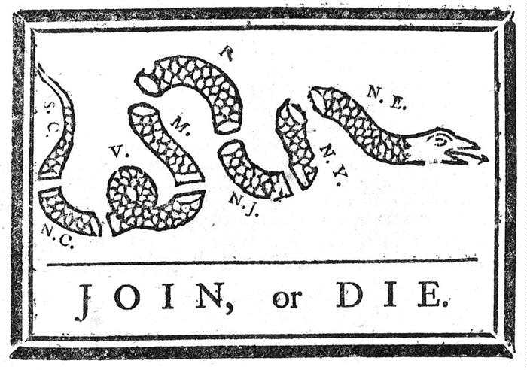
A powerful story from African traditions makes the same point as Franklin’s snake, in a different way. In this teaching legend, “One Stick, Two Sticks,” an old chief is about to die. He calls his tribe together and asks each to find two sticks. They do so, and then surround his deathbed. He asks each member to break one of the sticks, which they easily do. Even the smallest child has no trouble in snapping her stick in half. He then asks them to take all of their other sticks and tie them in a bundle. They do this, and then he invites anyone among them to break the bundle of sticks. No one can do it; even the strongest warriors cannot break the bundled sticks. “When we are alone, we are easily broken,” the chief tells them. “But when we are together, we are unbreakable.”
Franklin’s snake and this African teaching story matter to me. Unity. It’s getting close to sunset.

Send your personal coaching questions to kathleen@fullpotentialliving.com or call 473-4004. Kathleen is a personal and executive coach, clinical psychologist, and writer. (©2004 Kathleen Brehony. All Rights Reserved.) Columns are archived at www.fullpotentialliving.com.

